**Creating Microservices for account and loan**

**Question:** In this hands on exercises, we will create two microservices for a bank. One microservice for handing accounts and one for handling loans. Each microservice will be a specific independent Spring RESTful Webservice maven project having it's own pom.xml. The only difference is that, instead of having both account and loan as a single application, it is split into two different applications. These webservices will be a simple service without any backend connectivity.

**Code: (For Account)**

**AccountController.java:**

package com.cognizant.account;  
  
import org.springframework.http.ResponseEntity;  
import org.springframework.web.bind.annotation.GetMapping;  
import org.springframework.web.bind.annotation.PathVariable;  
import org.springframework.web.bind.annotation.RequestMapping;  
import org.springframework.web.bind.annotation.RestController;  
  
import java.util.HashMap;  
import java.util.Map;  
  
@RestController  
@RequestMapping("/accounts")  
public class AccountController {  
  
 @GetMapping("/{number}")  
 public ResponseEntity<Map<String, Object>> getAccount(@PathVariable String number) {  
 Map<String, Object> response = new HashMap<>();  
 response.put("number", number);  
 response.put("type", "savings");  
 response.put("balance", 10000);  
 return ResponseEntity.*ok*(response);  
 }  
}

**AccountApplication.java:**

package com.cognizant.account;  
  
import org.springframework.boot.SpringApplication;  
import org.springframework.boot.autoconfigure.SpringBootApplication;  
  
@SpringBootApplication  
public class AccountApplication {  
  
 public static void main(String[] args) {  
 SpringApplication.*run*(AccountApplication.class, args);  
 }  
}

**Output:**

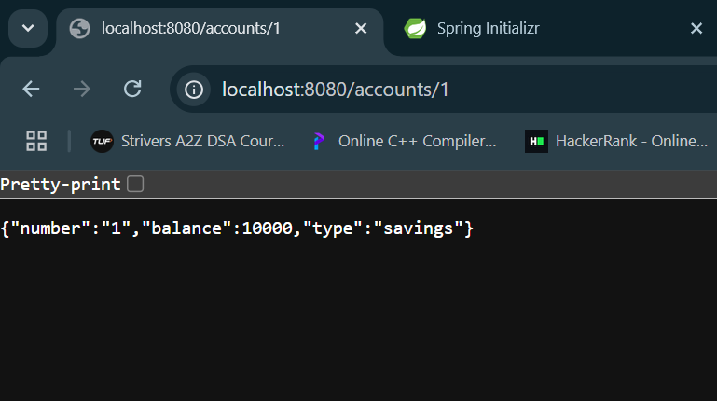

**Code:(For loan)**

**LoanController.java:**

package com.cognizant.loan;  
  
import org.springframework.http.ResponseEntity;  
import org.springframework.web.bind.annotation.GetMapping;  
import org.springframework.web.bind.annotation.PathVariable;  
import org.springframework.web.bind.annotation.RequestMapping;  
import org.springframework.web.bind.annotation.RestController;  
  
import java.util.HashMap;  
import java.util.Map;  
  
@RestController  
@RequestMapping("/loans")  
public class LoanController {  
  
 @GetMapping("/{number}")  
 public ResponseEntity<Map<String, Object>> getLoan(@PathVariable String number) {  
 Map<String, Object> response = new HashMap<>();  
 response.put("number", number);  
 response.put("type", "car");  
 response.put("loan", 400000);  
 response.put("empNo", 220808);  
 response.put("tenure", 18);  
 return ResponseEntity.*ok*(response);  
 }  
}

**LoanApplication.java:**

package com.cognizant.loan;  
  
import org.springframework.boot.SpringApplication;  
import org.springframework.boot.autoconfigure.SpringBootApplication;  
  
@SpringBootApplication  
public class LoanApplication {  
  
 public static void main(String[] args) {  
 SpringApplication.*run*(LoanApplication.class, args);  
 }  
  
}

**OUTPUT:**

